PRACTICAL-2 REVISION OF STRUCTURES
Problem-1
Aim:- Create a structure Student in C with student name, student roll number and student address as its data members. Create the variable of type student and print the values.
Theory:- First we created a structure Student with data members name, roll no and address. Then in the main function we made a structure variable s1. In it we entered details like name, roll no and address of student 1 and then we print these values.
Code:-
#include<stdio.h>
#include<string.h>
struct Student
{
char name[20];
int roll_no;
char address[100];
};
int main()
{
struct Student s1;
strcpy(s1.name,"Nirmit Jani");
s1.roll_no=86;
strcpy(s1.address,"M 41/244, Pragatinagar");
printf("Student Details:-\n");
printf("\nName:-%s\n",s1.name);
printf("Roll Number:-%d\n",s1.roll_no);
printf("Address:-%s\n",s1.address);
return 0;
}
Output:-
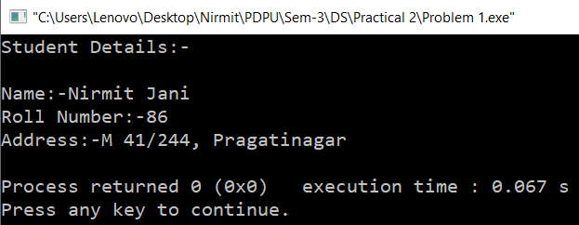
Time Complexity:- O(1) as it takes constant time to perform each operation and there is no loop.
Space Complexity:- O(1) as only one structure Student is there.
Problem-2
Aim:- Modify the above program to implement arrays of structure. Create an array of 5 students and print their values.
Theory:- In these first we created a structure Student and defined some data members. After that we created an array of structure of size 5 so that details of 5 students can be stored in it. We ran for loop for 5 times so as to enter the details of each student dynamically and then we print all the details of all students.
Code:-
#include<stdio.h>
struct Student
{
char name[20];
int roll_no;
char address[100];
};
int main()
{
struct Student s[5];
int i;
printf("Enter Student details:-\n");
for (i=0;i<5;i++)
{
printf("\nEnter Student %d details:-\n",i+1);
printf("Enter Name:-");
fgets(s[i].name,sizeof(s[i].name),stdin);
printf("Enter Roll number:-");
scanf("%d",&s[i].roll_no);
printf("Enter Address:-");
getchar();
fgets(s[i].address,sizeof(s[i].address),stdin);
}
printf("\nStudent Details:-\n");
for (i=0;i<5;i++)
{
printf("\nStudent %d details:-\n",i+1);
printf("Name:- %s",s[i].name);
printf("Roll Number:- %d\n",s[i].roll_no);
printf("Address:- %s\n",s[i].address);
}
return 0;
}
Output:-
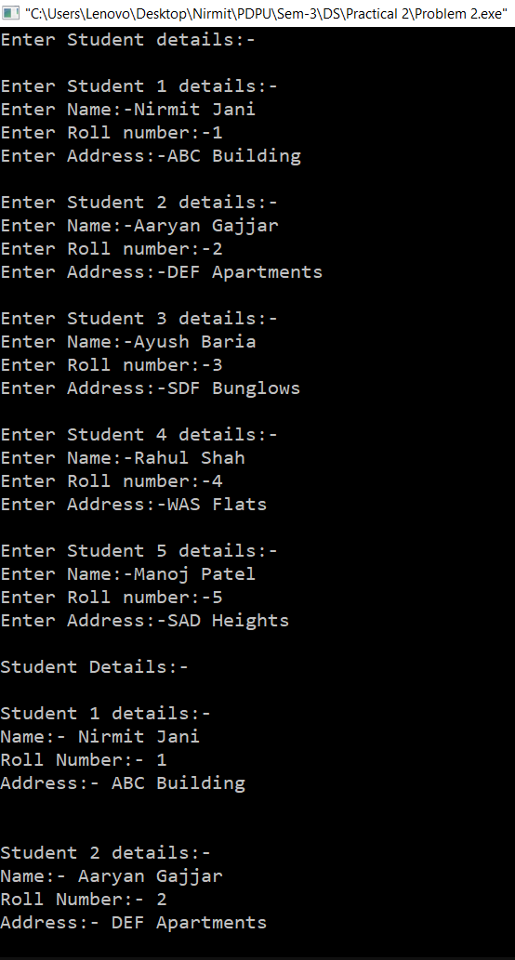
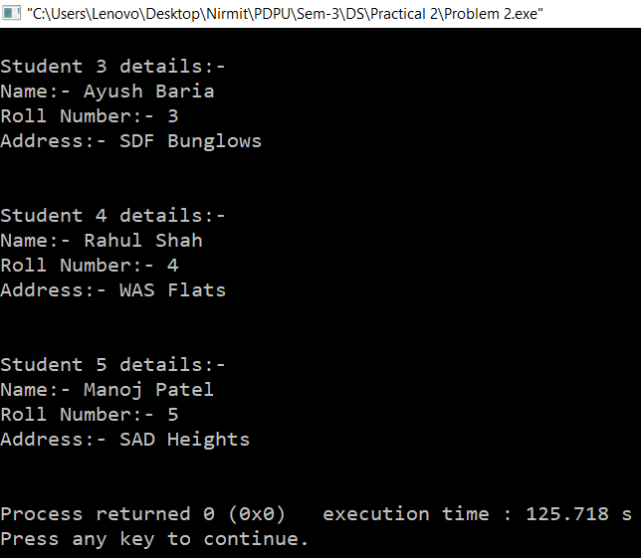
Time Complexity:- O(1) if we take constant time as here each loop the details reading and printing loop takes runs constant time that is 5.
O(n) if we generalize this to n students.
Space Complexity:- O(n) if generalized else O(1).
Problem-3
Aim:- Create a structure Organization with organization name and organization ID as its data members. Next, create another structure Employee that is nested in structure Organization with employee ID, employee salary and employee name as its data members. Write a program in such a way that there are two organizations and each of these contains two employees.
Theory:- We created a nested structure where we put a structure Employee in a structure Organization and defined some data members. Also we declared e[2] which means there will be exactly 2 employees in each organization. Then in main we defined array of structure of size 2 to make 2 organizations only. After that we took details dynamically and then printed them.
Code:-
#include <stdio.h>
struct Organization
{
char orgName[30];
int orgID;
struct Employee
{
int empID;
int empSal;
char empName[30];
} e[2];
};
int main()
{
struct Organization o[2];
int i,j;
for (i=0;i<2;i++)
{
printf("\nEnter Organization %d details:-\n",i+1);
printf("Name:-");
fgets(o[i].orgName,sizeof(o[i].orgName),stdin);
printf("ID:-");
scanf("%d", &o[i].orgID);
for (j=0;j<2;j++)
{
printf("Enter employee %d details:-\n",j+1);
printf("ID:-");
scanf("%d",&o[i].e[j].empID);
printf("Salary:-");
scanf("%d",&o[i].e[j].empSal);
printf("Name:-");
getchar();
fgets(o[i].e[j].empName,sizeof(o[i].e[j].empName),stdin);
}
}
for (i=0;i<2;i++)
{
printf("\nOrganization %d details:-\n", i + 1);
printf("Name:- %s",o[i].orgName);
printf("ID:- %d\n",o[i].orgID);
for (j=0;j<2;j++)
{
printf("Employee %d details:-\n", j+1);
printf("ID:- %d\n", o[i].e[j].empID);
printf("Salary:- %d\n", o[i].e[j].empSal);
printf("Name:- %s", o[i].e[j].empName);
}
}
return 0;
}
Output:-
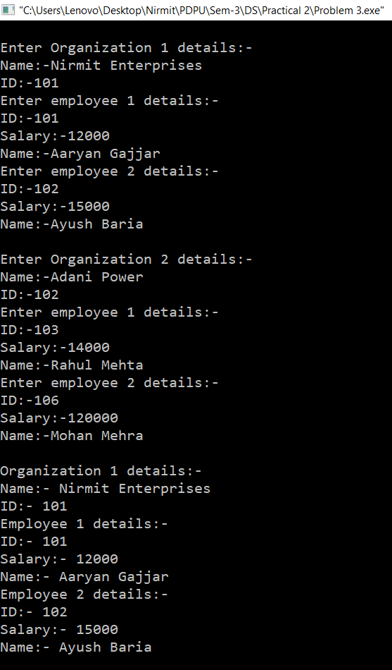
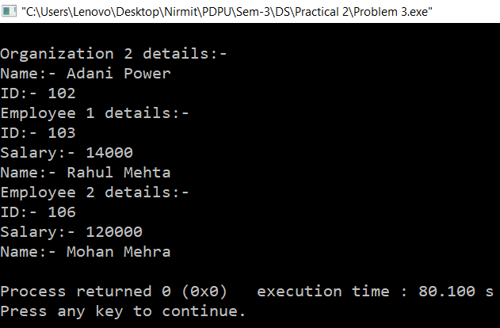
Time Complexity:- O(1) as only fix number of time the loop is running that is 2 times for 2 organizations and 2 times for 2 employee in each organization.
O(n x m) if we generalize to n organizations and m employees in each organizations.
Space Complexity:- O(n X m) where n is organizations and m is employees in each organizations.

